Bahria University,

Karachi Campus

LAB EXPERIMENT NO.

10

LIST OF TASKS

|  |  |
| --- | --- |
| TASK NO | OBJECTIVE |
| **1** | **Create an application named Debug Console** |
| 2 | **Create an application which can send broadcasts to the DebugConsole (above application).** |
|  |  |

Submitted On:

13 June2024

____________

(Date: DD/MM/YY)

**Task 1:**

**Create an application named Debug Console**

**Main.XML code**

<?xml version="1.0" encoding="utf-8"?>

<RelativeLayout xmlns:android="http://schemas.android.com/apk/res/android"

android:layout_width="match_parent"

android:layout_height="match_parent"

android:padding="16dp"

android:background="#E0F7FA">

<TextView

android:id="@+id/debugTextView"

android:layout_width="match_parent"

android:layout_height="wrap_content"

android:background="#ADD8E6"

android:textColor="#000000"

android:padding="10dp"

android:textSize="16sp"

android:scrollbars="vertical"

android:layout_marginBottom="16dp"

android:gravity="start"/>

<Button

android:id="@+id/sendDebugButton"

android:layout_width="wrap_content"

android:layout_height="wrap_content"

android:text="Send Debug Info"

android:layout_below="@id/debugTextView"

android:layout_centerHorizontal="true"/>

</RelativeLayout>

**Main.Java code**

package com.example.Lab;

import android.content.BroadcastReceiver;

import android.content.Context;

import android.content.Intent;

import android.content.IntentFilter;

import android.os.Bundle;

import android.text.method.ScrollingMovementMethod;

import android.view.View;

import android.widget.Button;

import android.widget.TextView;

import androidx.appcompat.app.AppCompatActivity;

public class MainActivity extends AppCompatActivity {

private TextView debugTextView;

private Button sendDebugButton;

@Override

protected void onCreate(Bundle savedInstanceState) {

super.onCreate(savedInstanceState);

setContentView(R.layout.activity_main);

debugTextView = findViewById(R.id.debugTextView);

sendDebugButton = findViewById(R.id.sendDebugButton);

debugTextView.setMovementMethod(new ScrollingMovementMethod());

IntentFilter filter = new IntentFilter("DEBUG_INFO");

registerReceiver(debugInfoReceiver, filter);

sendDebugButton.setOnClickListener(new View.OnClickListener() {

@Override

public void onClick(View v) {

Intent intent = new Intent(MainActivity.this, SendDebugActivity.class);

startActivity(intent);

}

});

}

@Override

protected void onDestroy() {

super.onDestroy();

unregisterReceiver(debugInfoReceiver);

}

private BroadcastReceiver debugInfoReceiver = new BroadcastReceiver() {

@Override

public void onReceive(Context context, Intent intent) {

String appName = intent.getStringExtra("appName");

String message = intent.getStringExtra("message");

String timestamp = String.valueOf(System.currentTimeMillis());

String log = String.format("Timestamp: %s\nApp: %s\nMessage: %s\n\n", timestamp, appName, message);

debugTextView.append(log);

}};}

**Debug.XML**

<?xml version="1.0" encoding="utf-8"?>

<RelativeLayout xmlns:android="http://schemas.android.com/apk/res/android"

android:layout_width="match_parent"

android:layout_height="match_parent"

android:padding="16dp"

android:background="#E0F7FA">

<EditText

android:id="@+id/messageInput"

android:layout_width="match_parent"

android:layout_height="wrap_content"

android:hint="Enter debug message"

android:padding="10dp"

android:textColor="@color/black"

android:layout_marginBottom="10dp"

android:textSize="16sp"/>

<Button

android:id="@+id/sendButton"

android:layout_width="wrap_content"

android:layout_height="wrap_content"

android:text="Send Debug Info"

android:layout_below="@id/messageInput"

android:layout_centerHorizontal="true"/>

</RelativeLayout>

**Debug.java code**

package com.example.Lab;

import android.content.Intent;

import android.os.Bundle;

import android.view.View;

import android.widget.Button;

import android.widget.EditText;

import androidx.appcompat.app.AppCompatActivity;

public class SendDebugActivity extends AppCompatActivity {

private EditText messageInput;

private Button sendButton;

@Override

protected void onCreate(Bundle savedInstanceState) {

super.onCreate(savedInstanceState);

setContentView(R.layout.activity_send_debug);

messageInput = findViewById(R.id.messageInput);

sendButton = findViewById(R.id.sendButton);

sendButton.setOnClickListener(new View.OnClickListener() {

@Override

public void onClick(View v) {

sendDebugInfoBroadcast(messageInput.getText().toString());

finish(); // Close the SendDebugActivity and return to MainActivity

}

});

}

private void sendDebugInfoBroadcast(String message) {

Intent intent = new Intent("DEBUG_INFO");

intent.putExtra("appName", "DebugConsoleApp");

intent.putExtra("message", message);

sendBroadcast(intent);

}}

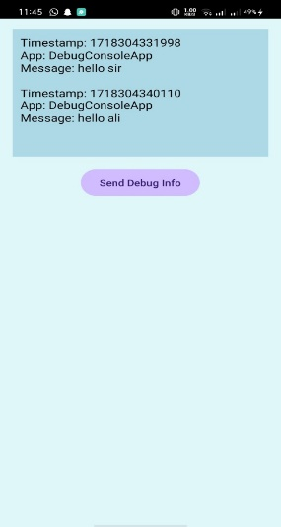**OUTPUT:**

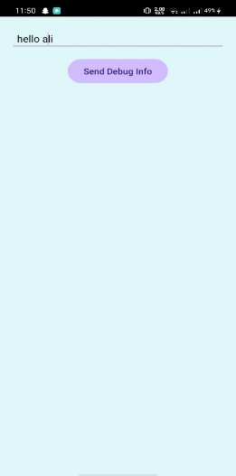

**Task 2:**

**Create an application which can send broadcasts to the DebugConsole (above application).**

**Main.XML code**

<?xml version="1.0" encoding="utf-8"?>

<RelativeLayout xmlns:android="http://schemas.android.com/apk/res/android"

android:layout_width="match_parent"

android:layout_height="match_parent"

android:padding="16dp"

android:background="#E0F7FA">

<TextView

android:id="@+id/debugTextView"

android:layout_width="match_parent"

android:layout_height="wrap_content"

android:background="#ADD8E6"

android:textColor="#000000"

android:padding="10dp"

android:textSize="16sp"

android:scrollbars="vertical"

android:layout_marginBottom="16dp"

android:gravity="start"/>

</RelativeLayout>

**MainJava code**

package com.example.Lab;

import android.content.BroadcastReceiver;

import android.content.Context;

import android.content.Intent;

import android.content.IntentFilter;

import android.os.Bundle;

import android.text.method.ScrollingMovementMethod;

import android.view.View;

import android.widget.Button;

import android.widget.TextView;

import androidx.appcompat.app.AppCompatActivity;

public class MainActivity extends AppCompatActivity {

private TextView debugTextView;

private Button sendDebugButton;

@Override

protected void onCreate(Bundle savedInstanceState) {

super.onCreate(savedInstanceState);

setContentView(R.layout.activity_main);

Intent intent = new Intent(MainActivity.this, SendDebugActivity.class);

startActivity(intent);

}

});

}

@Override

protected void onDestroy() {

super.onDestroy();

unregisterReceiver(debugInfoReceiver);

}

private BroadcastReceiver debugInfoReceiver = new BroadcastReceiver() {

@Override

s\nApp: %s\nMessage: %s\n\n", timestamp, appName, message);

debugTextView.append(log);

}};}

**Application2.XML code**

<?xml version="1.0" encoding="utf-8"?>

<RelativeLayout xmlns:android="http://schemas.android.com/apk/res/android"

android:layout_width="match_parent"

android:layout_height="match_parent"

android:padding="16dp"

android:background="#E0F7FA">

<EditText

android:id="@+id/messageInput"

android:layout_width="match_parent"

android:layout_height="wrap_content"

android:id="@+id/sendButton"

android:layout_width="wrap_content"

android:layout_height="wrap_content"

android:text="Send Debug Info"

android:layout_below="@id/messageInput"

android:layout_centerHorizontal="true"/>

</RelativeLayout>

**Application2.java code**

package com.example.Lab10;

import android.content.Intent;

import android.os.Bundle;

import android.view.View;

import android.widget.Button;

import android.widget.EditText;

import androidx.appcompat.app.AppCompatActivity;

public class SendDebugActivity extends AppCompatActivity {

private EditText messageInput;

private Button sendButton;

@Override

protected void onCreate(Bundle savedInstanceState) {

super.onCreate(savedInstanceState);

}

});

}

private void sendDebugInfoBroadcast(String message) {

Intent intent = new Intent("DEBUG_INFO");

intent.putExtra("appName", " Lab10Application");

intent.putExtra("message", message);

sendBroadcast(intent);

}}

**OUTPUT:**

